Xprint Installation

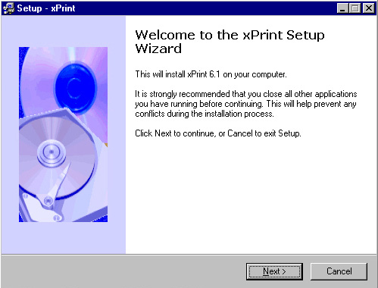

Double click on the xPrint6. The first menu will be the Welcome to the Xprint Setup Wizard.

Click Next

License Agreement

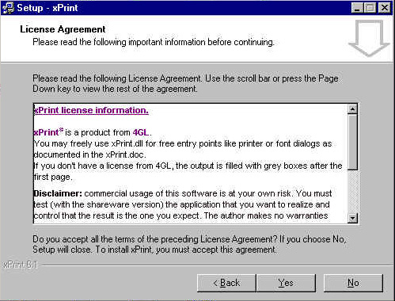

View the License Agreement screen

Click YES

Select Destination Directory

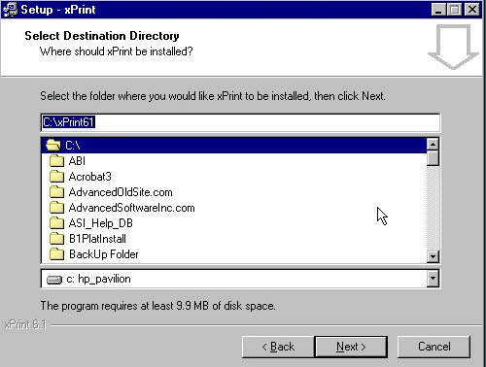

Select the directory. Use default settings.

Click Next

Select Progress Binary Directory

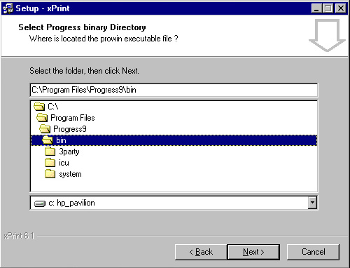

Select the Progress Binary Directory from the list. Please take note of the path destination of the directory.

Program Files/Progress/bin - this is where you need to install the program files to make it work right.

Click Next

Select Start Menu Folder

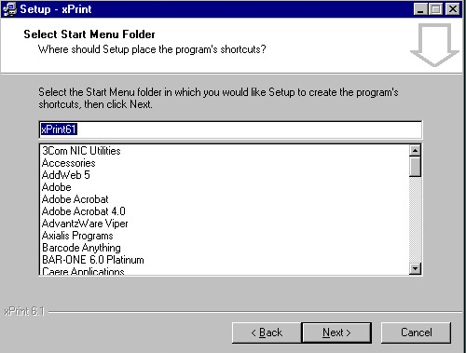

Keep the default installation as above.

Click Next

Select Additional Tasks

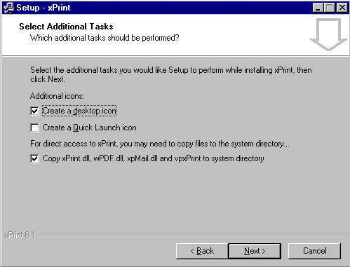

Please keep the default check boxes for you installation.

Click Next

Ready to Install

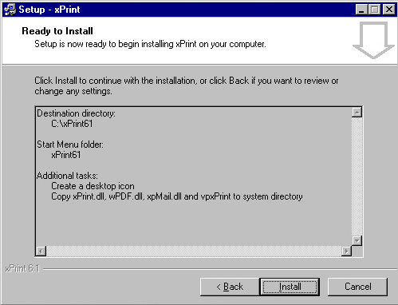

Click the install button to complete the installation of the software.

Click Install

